Methods

Feature Normalization

Features used in conjunction with the graph convolution are computed with the RDKit toolkit[X]. The neural network architecture requires that the features are appropriately scaled to prevent features with large ranges dominating smaller ranged features as well as preventing issues where features in the training set are not drawn from the same sample distribution as the testing sets. prevent these issues, a large sample of molecules was used to fit cumulative density function (CDF) to all features. CDF were used as opposed to simpler scaling algorithms mainly because CDFs have the useful property that each value has the same meaning: the percentage of the population observed below the raw feature value. Min-max scaling can be easily biased with outliers and Z-score scaling assumes a normal distribution which is most often not the case for chemical features, especially if they are based on counts.

The CDFs were fit to a sampling of 100k compounds from the Novartis internal catalog using the distributions available in the scikit learn package[X], a sampling of which can be seen in Figure X. scikit learn was used primarily due to the simplicity of fitting and the final application, however more complicated techniques can be used in the future to fit to empirical CDFs such as finding the best fit general logistic function[X] which has been shown to be successful for other biological datasets. The sample distributions and fits are available in the supplementary material. No review was taken to remove odd distributions; for example, azides are hazardous and rarely used outside of a few specific reactions. This is reflected in the fr_azide distribution. As such, since the sample data was primarily used for chemical screening against biological targets, the distribution used here may not accurately reflect the distribution of reagents used for chemical synthesis.

Future work should include detecting ill-fitting distributions, such as for fr_pyridine as seen in Figure X, and using alternative methods, such as empirical distributions.
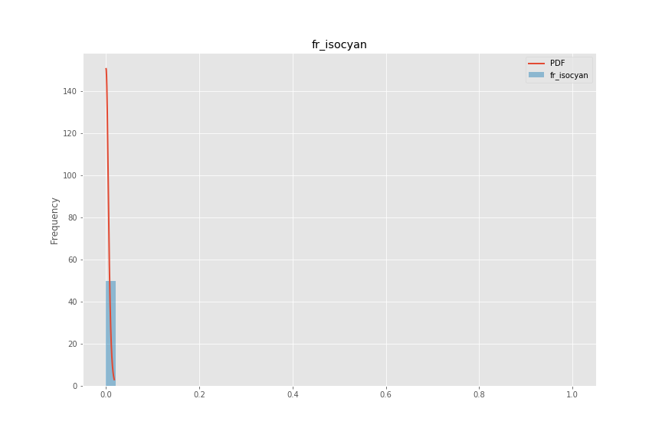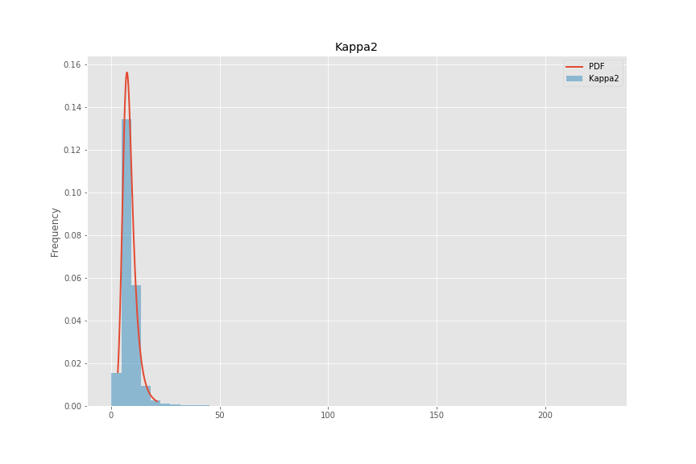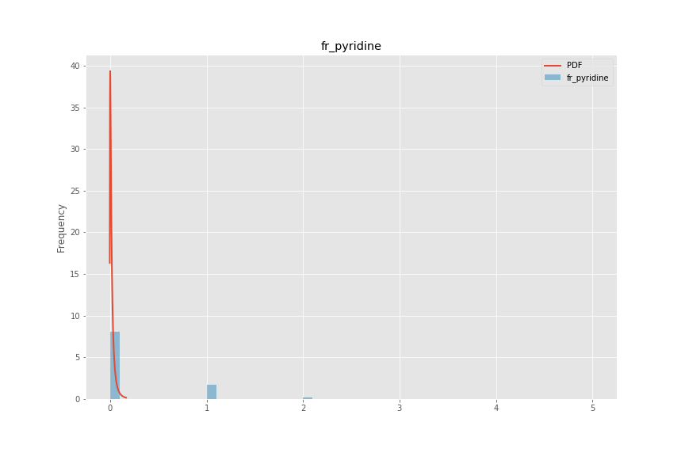
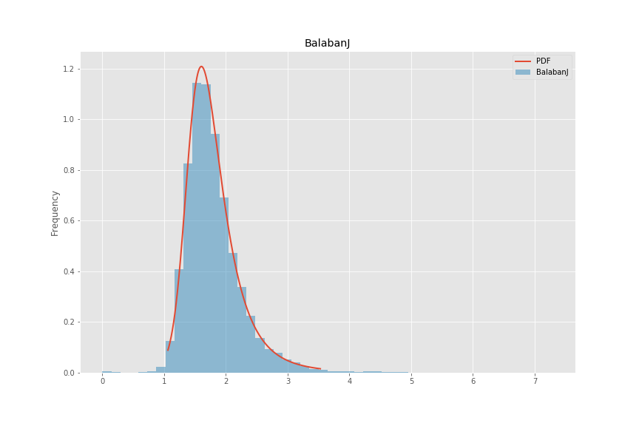
Figure 1 Four example distributions fit to a random sample of 100,000 of compounds used for biological screening in Novartis. Note that some distributions for discrete calculations, such as fr_pyridine are not fit especially well. This is an active area for improvement.

List of descriptors used:
- BalabanJ
- BertzCT
- Chi0
- Chi0n
- Chi0v
- Chi1
- Chi1n
- Chi1v
- Chi2n
- Chi2v
- Chi3n
- Chi3v
- Chi4n
- Chi4v
- EState_VSA1
- EState_VSA10
- EState_VSA11
- EState_VSA2
- EState_VSA3
- EState_VSA4
- EState_VSA5
- EState_VSA6
- EState_VSA7
- EState_VSA8
- EState_VSA9
- ExactMolWt
- FpDensityMorgan1
- FpDensityMorgan2
- FpDensityMorgan3
- FractionCSP3
- HallKierAlpha
- HeavyAtomCount
- HeavyAtomMolWt
- Ipc
- Kappa1
- Kappa2
- Kappa3
- LabuteASA
- MaxAbsEStateIndex
- MaxAbsPartialCharge
- MaxEStateIndex
- MaxPartialCharge
- MinAbsEStateIndex
- MinAbsPartialCharge
- MinEStateIndex
- MinPartialCharge
- MolLogP
- MolMR
- MolWt
- NHOHCount
- NOCount
- NumAliphaticCarbocycles
- NumAliphaticHeterocycles
- NumAliphaticRings
- NumAromaticCarbocycles
- NumAromaticHeterocycles
- NumAromaticRings
- NumHAcceptors
- NumHDonors
- NumHeteroatoms
- NumRadicalElectrons
- NumRotatableBonds
- NumSaturatedCarbocycles
- NumSaturatedHeterocycles
- NumSaturatedRings
- NumValenceElectrons
- PEOE_VSA1
- PEOE_VSA10
- PEOE_VSA11
- PEOE_VSA12
- PEOE_VSA13
- PEOE_VSA14
- PEOE_VSA2
- PEOE_VSA3
- PEOE_VSA4
- PEOE_VSA5
- PEOE_VSA6
- PEOE_VSA7
- PEOE_VSA8
- PEOE_VSA9
- RingCount
- SMR_VSA1
- SMR_VSA10
- SMR_VSA2
- SMR_VSA3
- SMR_VSA4
- SMR_VSA5
- SMR_VSA6
- SMR_VSA7
- SMR_VSA8
- SMR_VSA9
- SlogP_VSA1
- SlogP_VSA10
- SlogP_VSA11
- SlogP_VSA12
- SlogP_VSA2
- SlogP_VSA3
- SlogP_VSA4
- SlogP_VSA5
- SlogP_VSA6
- SlogP_VSA7
- SlogP_VSA8
- SlogP_VSA9
- TPSA
- VSA_EState1
- VSA_EState10
- VSA_EState2
- VSA_EState3
- VSA_EState4
- VSA_EState5
- VSA_EState6
- VSA_EState7
- VSA_EState8
- VSA_EState9
- fr_Al_COO
- fr_Al_OH
- fr_Al_OH_noTert
- fr_ArN
- fr_Ar_COO
- fr_Ar_N
- fr_Ar_NH
- fr_Ar_OH
- fr_COO
- fr_COO2
- fr_C_O
- fr_C_O_noCOO
- fr_C_S
- fr_HOCCN
- fr_Imine
- fr_NH0
- fr_NH1
- fr_NH2
- fr_N_O
- fr_Ndealkylation1
- fr_Ndealkylation2
- fr_Nhpyrrole
- fr_SH
- fr_aldehyde
- fr_alkyl_carbamate
- fr_alkyl_halide
- fr_allylic_oxid
- fr_amide
- fr_amidine
- fr_aniline
- fr_aryl_methyl
- fr_azide
- fr_azo
- fr_barbitur
- fr_benzene
- fr_benzodiazepine
- fr_bicyclic
- fr_diazo
- fr_dihydropyridine
- fr_epoxide
- fr_ester
- fr_ether
- fr_furan
- fr_guanido
- fr_halogen
- fr_hdrzine
- fr_hdrzone
- fr_imidazole
- fr_imide
- fr_isocyan
- fr_isothiocyan
- fr_ketone
- fr_ketone_Topliss
- fr_lactam
- fr_lactone
- fr_methoxy
- fr_morpholine
- fr_nitrile
- fr_nitro
- fr_nitro_arom
- fr_nitro_arom_nonortho
- fr_nitroso
- fr_oxazole
- fr_oxime
- fr_para_hydroxylation
- fr_phenol
- fr_phenol_noOrthoHbond
- fr_phos_acid
- fr_phos_ester
- fr_piperdine
- fr_piperzine
- fr_priamide
- fr_prisulfonamd
- fr_pyridine
- fr_quatN
- fr_sulfide
- fr_sulfonamd
- fr_sulfone
- fr_term_acetylene
- fr_tetrazole
- fr_thiazole
- fr_thiocyan
- fr_thiophene
- fr_unbrch_alkane
- fr_urea
- qed

[X] RDKit 2018.09.01
[X] scikit learn version …

